**Project Design Phase-II**

**Data Flow Diagram & User Stories**

|  |  |
| --- | --- |
| **Date** | **19/10/2022** |
| **Team ID** | **PNT2022TMID23524** |
| **Project Name** | **Smart Solutions for Railways** |
| **Maximum Marks** | 4 Marks |

**SUBMITTED BY**

**SWETHA .G (113219041121)**

**MEENA.C (113219041066)**

**RASIKA.J (113219041094)**

**MALAVIKA.R (113219041062)**

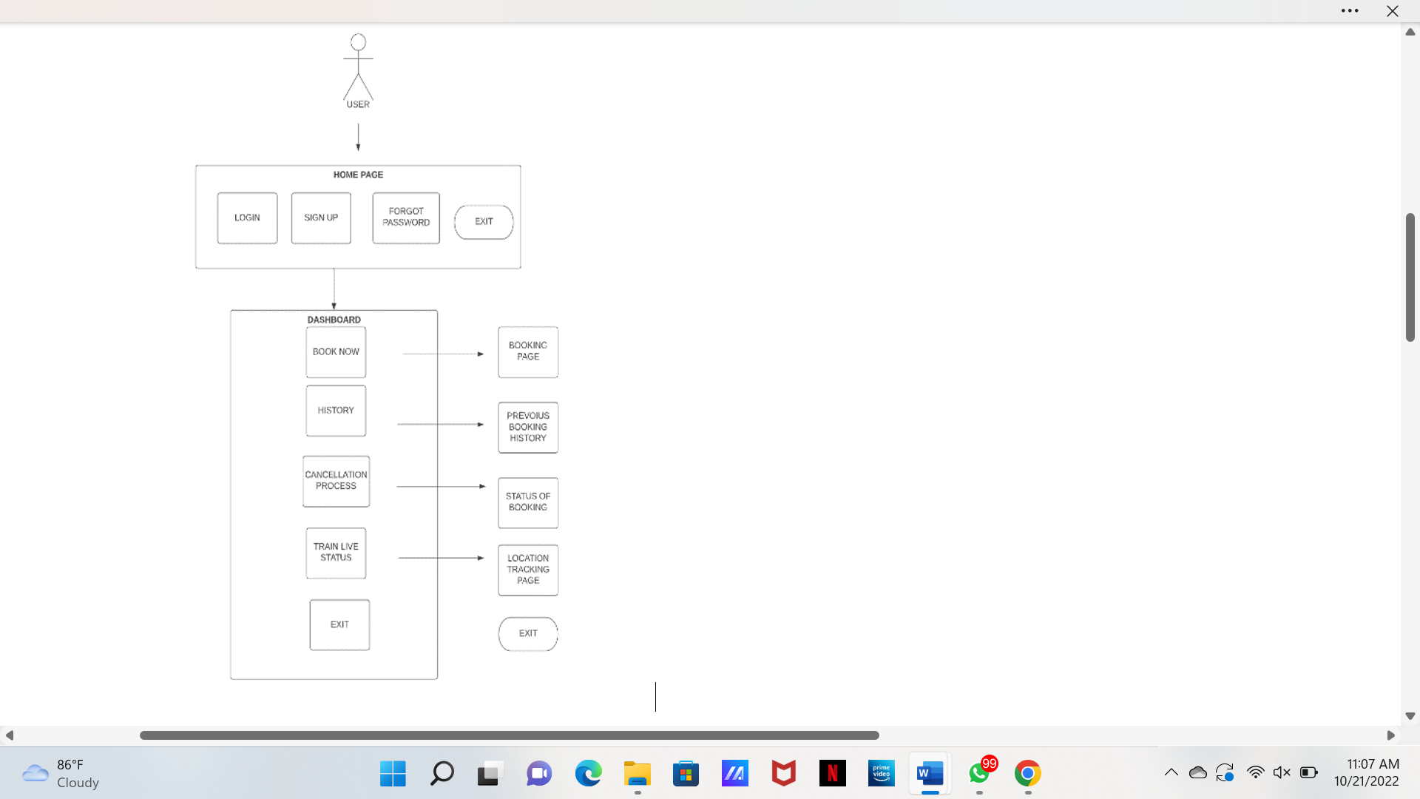**Data Flow Diagrams:**

* Railway Reservation System Data flow diagram is often used as a preliminary step to create an overview of the Railway Reservation without going into great detail, which can later be elaborated.it normally consists of overall application dataflow and processes of the Railway Reservation process.

**User Stories**

Use the below template to list all the user stories for the product.

|  |  |  |  |  |  |  |
| --- | --- | --- | --- | --- | --- | --- |
| **User Type** | **Functional**  **Requirement**  **(Epic)** | **User Story**  **Number** | **User Story / Task** | **Acceptance criteria** | **Priority** | **Release** |
| Customer  (Mobile user) | Reserving ticket | USN-1 | As a user, I can register for the application by entering my email, password, and confirming my password. | I can access my account / dashboard | High | Sprint-1 |
| Customer  (Mobile user) | Reserving ticket | USN-2 | As a user, I will receive confirmation email once I have registered for the application | I can receive confirmation email & click confirm | High | Sprint-1 |
| Customer  (Mobile user) | Reserving ticket | USN-3 | As a user, I can register for the application and enter the details for reserving the ticket | I can register & access the dashboard with Facebook  Login | Low | Sprint-2 |
| Customer  (Mobile user) | Dashboard | Users | The details will be stored safely | I can access it using  database | Medium | Sprint-3 |
| Customer (Web  user) | Reserving ticket | user | Enter the details and click submit button to book ticket | I can use the QR code  which is been generated | High | Sprint- 1 |
| Customer Care  Executive | Connecting the  service provider | customer | Connects with the service by logging in | Can get connected with  the server | Medium | Sprint-3 |
| Administrator | Provides the  services | admin | The data is given by the user | Can add or update the  data provided by the user | High | Sprint-1 |